Welcome to the Children and Families International Foundation:
Supporting Social Work in Malawi (SSWIM) Supporter’s Newsletter 2025-2026

A message from the Trustees
Children and Families International Foundation (CFIF) was first registered as a charity in 2007, so it’s not long to our 20th anniversary! We have always been a small charity, totally reliant on the skills and expertise which our members give so freely, and on the donations which our supporters give so generously. However, the impact we have had, particularly through working alongside our colleagues and friends in Malawi, is invaluable. So, a big thankyou to all concerned.
We currently have five trustees and rightly take seriously our responsibilities in terms of the governance of the charity. We aim to meet at least twice yearly, either online or directly, with our most recent meeting held in February 2026 in Birmingham, where BASW kindly makes meeting facilities available to us. At that meeting we were reflecting on the progress, and the pitfalls of the last 18 years, considering future plans, and agreeing the steps we need to take to ensure that CFIF is in every way ‘fit for purpose’.
At our AGM held in October 2025 we reviewed the Financial Accounts for 2024, as prepared by our Treasurer, Simba Maposa and confirmed that the necessary financial controls were in place. The Annual Accounts show our total incoming resources as being £15474 and total resources expended as being £15733. It should be noted however that our ‘resources’ reflect primarily the value ascribed to the time and expertise which our members have given to the work we undertake. Inevitably as a registered charity we have some administrative costs, but we keep these to an absolute minimum (averaging less than £500 per annum) so that all the regular and one off donations we receive can go to supporting directly the work we do.
This Newsletter will tell you about that recent work, in particular the activities of our key initiative –
Supporting Social Work in Malawi (SSWIM).
Although supporting ‘social work’ may seem to be a very specific area and one which not all our donors will have experience in, please do remember that social work and social workers touch the lives of very many of our most vulnerable individuals, families and communities…so our reach goes far beyond social work academia and practice. Our aim has always been to work with and not for those individuals and communities, and to ensure that whatever we do we are guided by those we seek to help, and by a principle of sustainability. Hopefully our track record of almost 20 years evidences our commitment to the long road to meaningful change.
If you would like to know more about the role of trustee, we would be pleased to meet with you; we are always seeking to bring new interest and experience to our trustee body and in particular the trustees would benefit from having a colleague who is able to bring fundraising expertise.

CFIF Trustee Board and the governance of SSWIM
CFIF has been a registered charity since 2007 and currently has 5 trustees - Anstance Fometu, Chair of the Trustees; Christine Mungoshi, who is a past member of the International Committee of British Association of Social workers (BASW), Dr Janet Walker (Honorary Professor (International Social Work) University of Lincoln), Chris Smith, our Secretary, and Simba Maposa, our Treasurer. Our Annual Return to the Charity Commission is submitted annually as required, prepared as always with thoroughness by Simba. You can find this on the Charity Commission website, entering CFIF’s registered charity number 1122885.

SSWIM Steering Group
The Steering Group comprises a core group of social work academics and practitioners across the UK who meet two or three times annually. We held 2 face to face meetings in 2025; in February and September we met at the BASW offices in Birmingham, with grateful thanks to BASW for welcoming and making their facilities available to us. Our final meeting of the year was online in December.
Our primary focus is on supporting the development of social work and social workers in Malawi. We achieve this through working in partnership with universities delivering social work and continuing development of social workers in Malawi, particularly the University of Malawi, Magomare College and the Catholic University. We support the Association of Social Workers in Malawi in the development of social work in Malawi. We work with the Government Ministries responsible for social work to inform and support their work. We collaborate with relevant organisations and NGO’s who support the work of social work. Nottingham Trent University and the University of Lincoln continue to support us through the involvement of Dr Simon Cauvain and Dr Janet Walker.

As a charity, we approach this work by listening, learning and engaging with practitioners, colleagues and others with humility and great respect for their work, especially in challenging circumstances. We seek to ensure that any project we engage in is locally grounded, indigenously grounded, culturally relevant and addressed equitably. Our aim is to recognise and support local knowledge and practices and exchange knowledge and skills. We hope this can enhance the significant contribution of social workers and social work to a sustainable future for the profession and for the citizens of Malawi.

SSWIM activities in Malawi during 2025

In May 2025 Dr Janet Walker and Dr Simon Cauvain returned to Malawi for their annual visit and spent a busy week in Malawi. They worked together with the universities in Malawi that we support; meeting with Association of Social Workers in Malawi (ASWIM) representatives to hear more about their developments; and to consider how we can support them over the next year.

Janet and Simon’s itinerary for the week included teaching students from two universities; meeting the latest staff team at the University of Malawi; field trips (Children’s Corner and Centre for People with Disabilities); an online CPD session for social workers; meeting ASWIM officials and reviewing the proposed MA programme for social workers. Simon also took out some deflated handballs and rugby balls donated by his local school.

Here is their account of that week which gives a real flavour of our field trips to Malawi:
Day 1 Teaching - ‘We had a great day working with representatives from all four cohorts of the BA Social Work course. As always, we learn so much from our students. Great to hear Malawian perspectives during this highly interactive session’.

Day 2: Visits “ Austin and Oscar collected us a little later as the usual car broke down so an alternative needed to be found. We picked up Stefano in Limbe and then a short distance onto Blantyre to meet George Chiusiwa, Director General at Malawi Council for Disability Affairs (MACODA). This was a wonderfully progressive discussion followed introductions where George outlined his background, the context of service, the new law Persons with Disabilities Act 2024, the central role of social work to the success of his organisation and how we might work together to achieve objectives. We spend a few hours together and covered the following items and themes: working relationships between MACODA, University of Malawi (UniMa) and ASWIM, Social Work Law and Policy, Public Relations and Media, MA postgraduate social work education, placements, employment, funding and research bids, inter-disciplinary study and working, the Service User (lived experience) voice. We are making progress and George is a strong ally for social work… there is much to do. Preparing for tomorrow with students and then the Catholic University.

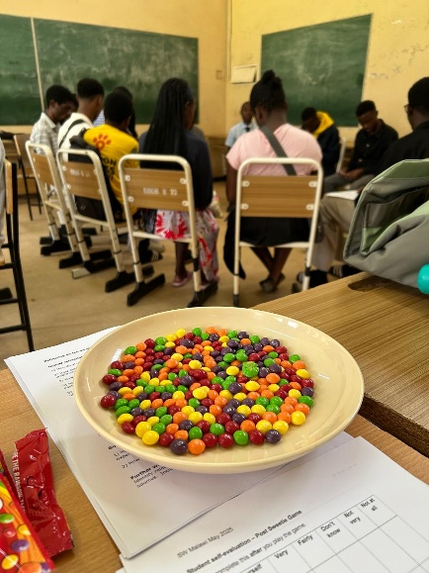
Day 3: The Sweetie Game: Malawi style. This morning we enjoyed working with 30 students from each cohort of the social work course, psychology students and a history student. The first task after introductions was to explain the planned session - the 'sweetie game' with a Malawian perspective. This is a session about empathy, power, privilege where we were walking in the shoes of another (and eating Skittles!) The group split into two; one to review a set of characters and change them where necessary to fit the Malawian context; the other group reviewed a set of questions about everyday things many take for granted (e.g. access to local shops and other service buildings).

This attempt at decolonising was embraced and appreciated by the group. Once characters and questions were ready, more was discussed on the purpose of the game, to consider empathy, power, privilege, discrimination, anti-oppressive practice etc.

The game began. Characters were randomly distributed in an envelope, and all were asked to step into the shoes of their character. E.g. a 40 year old Asian male, a 16 yr old single mother. I asked a question, if answer in character was yes you take a sweet. If no you stay put. After ten questions (due to time) we counted up sweets and revealed characters by counting down from ten to zero.

We then discussed characters and reasons for yes/no responses. These students each engaged throughout and were brilliant, insightful and giving in their energy and enthusiasm. They talked of cultural and physical barriers, prejudices, action to change, responsibility to uphold human rights, social justice, law and equality. A truly humbling experience. The student feedback was great and Austin plans to use this game in his teaching. We handed over materials and some students explained how they could use this game in their own practice.

Day 4: Meeting with ASWIM
Weather has been lovely today after much cloud and some rain. Janet and I provided our photos for an ASWIM webinar poster for Thursday. and prepared our materials on professional identity (Janet) and ethics (Simon).
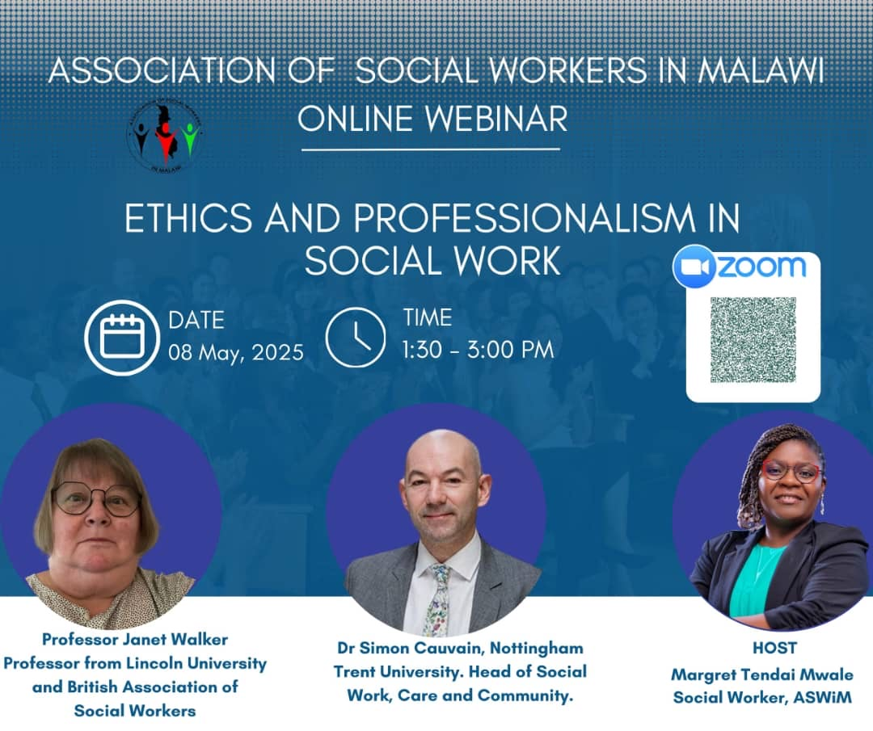
We had the day booked for a meeting with Stephano. We talked through so many themes and had a truly great meeting. We reflected on the previous meeting with George and agreed it was groundbreaking. Themes turned to agreed actions and included website and ASWIM promotion, review of current ASWIM activities, future plans including non-academic publications, Practice Education and CPD, mapping exercise including Stephano's networks, MA Social Work plans.
The recorded webinar was conducted in Janet's room. Introductions were made by Stephano and Maggie to what appeared to be 3 people. It was only later we learned there were 42 Malawian social workers attending! Feedback was very kind and appreciative. Engagement was good after Maggie posed initial questions. The call for ASWIM representation and SW collectivism was heard loud and clear. The need to protect title and uphold professional standards, whistle blowing and fitness to practise were also discussed. The 90 minutes flew by. Janet and I reflected on how much we enjoyed this event and the potential for positive impact as we reportedly covered topics not collectively discussed in this way before.

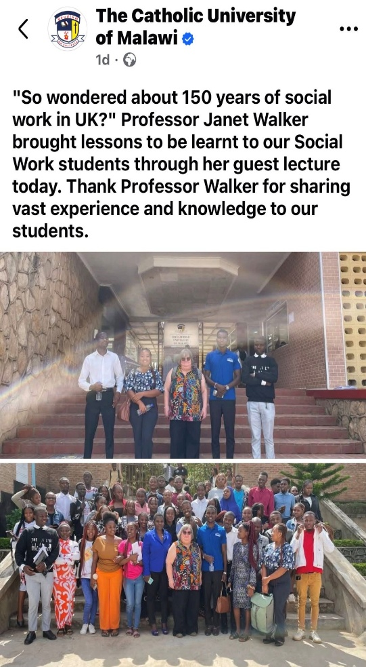
Day 5: Janet and Simon went their separate ways; Janet went to the Catholic University with 2 of University of Malawi students - President and Vice President of the Social Work Society. Simon was delivering donated balls to a Children's Corner.

Janet “At the Catholic University we met the Head of Social Work, Dean of Social Sciences, Head of Partnerships and Vice Chancellor! All keen to work with us! They are also developing a MSW. There was a great crowd for the lecture, and it seemed to go down well. The students talked about ways the SW students could work together - greater with a big round of applause. They were also keen to support the work of ASWIM!

Simon “This was a day I'll never forget and a reminder of why we're supporting social work in Malawi.”

My lift arrived - I politely turned down a croggy on the back of Million's motorbike .with the 22kg case strapped to the back and travelled instead in the now fixed truck for the 25km journey to the other side of Zomba.( Million is a newly qualified social worker) The back roads were dry but affected by previous floods so it was good to be in a truck with suspension. I didn't know what to expect on arrival but this video clip - https://youtu.be/Jwh3D7trCpg gives you an idea how powerful an experience this was.

We met the headteacher, did introductions and signed the visitor book. He explained there were 1427 children attending with 12 teachers. Quite remarkable. The walls were surrounded by charts of children's names, dates, times and subjects. No time for photos at this stage as we had balls to inflate. Million has previously delivered them intact. This was his childhood village and an area he knows is important to return to.

We gathered around and received presentations overseen by Joy, one of the facilitators. Joy went first then a selection of children ticked an emotion and explained why they felt that way. One was sad but happy we were there. The other five said they were happy. I followed Taonga to express how happy I was to be there and to have received such a powerful welcome. I explained the rugby and handballs were kindly donated by Park Vale Academy, Nottingham where my University and football team (red top) were from.
Patrick (around 10yrs old) then presented a life journey map of the highs and lows he'd experienced. This was also moving and included mention of previous floods and losing his home. We had a great high five as he rejoined the group. Then onto the playing field.
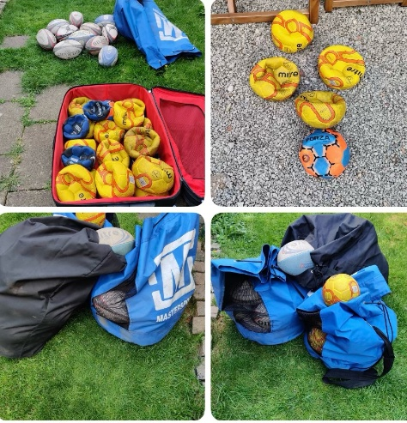
Once the balls and three of Janet's frisbees were gathered again with the children in a huge circle. Million asked me to demonstrate how to use each of the three items. As you'll see from the clip, in reality, the children were making a perfect job of it on their own. That said I loved the chance to throw (and kick) the rugby ball, throw the frisbee and do some kick ups with a handball. Great fun! With that it was a brief chance to throw frisbee with the children, do lots of gentle fist bumps,, spoke with one boy with great English who was advocating for his peers explaining how appreciated our visit was and how vulnerable some of the children were. Austin and Taonga each then spoke with separate groups of children about importance of education. And with that, after many more gentle fist bumps, thumbs up, waves and smiles we were back in the truck and on our way down the dusty tracks. By the time we got to the main road the sun had set.

I reflected on what an honour it was to do this today. How I wish I had 100 cases full of new balls and frisbees! I also had a sense of guilt that I only brought one case full of second hand balls. But seeing the children playing in that field and hearing Austin say how happy we had helped them feel, brought tears to my eyes. A truly humbling experience. I promised to return and am already looking forward to it.

Message from Team ASWIM, MALAWI
We were delighted to receive this message from our colleagues at ASWIM reflecting on the trip-
“ Janet and Simon, as you leave Malawi for UK today after a successful tour of duty, let me wish you a safe trip back home. It has been an amazing week for social work in Malawi. The public lectures and drills with students from UNIMA and the Catholic University of Malawi, the visit to MACODA, what an eye opener and learning experience for ASWiM, the highly attended webinar for social workers in Malawi tapping into your experience and cross learning and crowning it all with a visit to Milala Children's Corner in Zomba where over 250 children gathered and received a donation of balls and stimulation in mental health, education and interaction in various games. This was indeed a successful trip. As ASWiM we value this partnership and support and look forward to more areas of technical support and cooperation for the advancement of social work in Malawi. When you go back always remember Malawi as we still have more areas that require support. To the University of Malawi, thank you very much for the cooperation. ASWiM was born under you, and we will remain indebted as we work towards transforming the social work landscape in Malawi.

Reply from Simon to Stephano and ASWIM
Thank you, Stephano, and ASWiM for the kind words that mean so very much. This has indeed been a meaningful and humbling visit full of activity and progress. Thank you as always to you and UniMa, Austin and students for all those interactions across the week. We work in meaningful partnership and strive for enduring impact in all we do together. Onwards and upwards. Viva Social Work in Malawi!

Visit to Malawi by Kate Aspray
In the last newsletter Kate Asprya, who is now on the steering group introduced herself and how she had become involved with SSWIM . Kate is a qualified social worker, working in the North East of England in Children’s Social Care and her family have a connection to the Queen Elizabeth Hospital in Blantyre .

During this year together with her sister, who is a Speech and Language Therapist, they went out to Malawi in March 2025 with the Children with Cancer in Malawi group. Their aim was to understand more about the work within the hospital, the current work of social workers in hospital and community settings, and the potential for future links and placement opportunities for social work students. Kate also then travelled on to Zomba to visit the University of Malawi to learn about the experiences of social work students there.

During her first week Kate specifically ‘shadowed’ the hospital social worker, Sharon, who is a safeguarding lead in respect of violence against women and children, an immensely challenging role. She also liaised with the multi-agency professionals working with children with disabilities and their families, particularly around a nutrition programme. She hopes to continue to build on these links now she has returned to the UK.

In her second week in Zomba, primarily at the University of Malawi Kate met with many staff and students, including those studying subjects other than social work, and delivered a seminar focussed on themes in child protection in social work. On World Social Work Day she visited a centre for orphan children which ‘bridges the gap’ for those living with extended family.

Developments of the Association of Social Workers in Malawi (ASWIM)
ASWIM was established in 2019 as a not-for-profit membership organisation, aimed at promoting the professionalisation, advancement and protection of social work professionals in Malawi, focusing on social workers, social service providers and users. Their development has been actively supported by the work of SSWIM. ASWIM actively works to promote social work in Malawi to represent the social work professional at local, regional and national levels. They are founded on ASWIM It has a National Executive Committee (NEC) to guide, support and develop its work. Recent elections were held which resulted in a new Chair being appointed. ASWIM has a constitution and code of ethics which gives guidance to the works of the Association and has chapters in the northern, central, eastern, and southern regions of Malawi. In addition to providing training events and seminars for its members there is also a Malawi Social Workers WhatsApp group which now numbers over 1000 members. They are working with relevant Government Departments, including promotion of the Social Work Bill, which will support the recognition and professionalisation of social work in Malawi. They are increasingly active in the global arena through their membership of the International Association of Social Workes – Africa; representation on IFSW Global Ethics Committee; and representation on the Commonwealth Organisation of Social Workers (COSW). The reciprocal sharing of tasks and advice to support the work development of ASWIM is greatly valued by all parties.

Funding can support this work through identified projects and activities and a critical social work activity that is a direct response to a national issue or emergency.

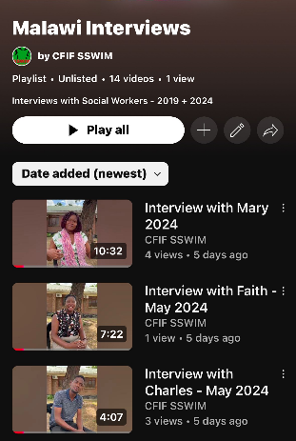
Interviews with Social Workers in Malawi
We have been recording interviews with social workers in Malawi in the last few years inviting them to share their practice and response to vulnerable people and communities. The give a real insight to he commitment of individual social workers practicing in Malawi as well as the challenges. We try to highlight individual interviews periodically on World Social Work day or Internation Women’s Day etc. Do share them with friends and colleagues who might be interested in them. There are 11 original interviews recorded back in 2019 and a further 3 interviews recorded in 2024 with Charles, Faith and Mary. You can view them on our YouTube channel using the following link – https://www.youtube.com/playlist?list=PLl2JjwP5CJqbTaVYI8AR_82s5INmPuscS

Research and writing group.
The Research and Writing Group, as a partnership between the University of Malawi, ASSWIM and SSWIM, has been established to support the promotion, reporting and active research of social work in Malawi. Colleagues in Malawi have been mentored, producing documents and reports and writing for publication. Social work in Malawi has been represented through successful submission of papers to conferences. Examples include two well received presentations at the Global Social Work Conference 2024 in Panama (2024) - Social work at the ‘frontline’ in disaster management: learning from Malawi and Learning in Practice for Students: Creating an indigenous, professional identity for social work in Malawi - and a forthcoming presentation - Creating a professional identity for social work in Malawi: Learning for Africa - at the Global Social Work Conference 2026 in Kenya. we have jointly produced a chapter for an international textbook – Walker, J., Cauvian, S., Kakowa, F. and Fometu, F. (2024) . Social Work Education and Practice Education, Decolonisation and Ubuntu: Making Connections in Malawi . In Susan Levy, Uzoma Odera Okoye, Plus T. Tanga and Richard Ingram (eds) Routledge Handbook on African Social Work Education, London: Routledge pp 370-381. A co-writing plan has been established to produce writing for publication to support and highlight the work of social workers. This includes Indigenous knowledge/practice embedded in social work practice and implications for the social work curriculum) and engaging with communities in Malawi.

Funding can support this work through providing opportunities to meet and collaborate and supporting colleagues in Malawi to attend relevant events and conferences to promote social work in Malawi, provide networking opportunities and support professional development

How you can support SSWIM
Fundraising
We have received an increase of small regular donations from people who have set up a monthly direct debit to support SSWIM’s work which has been a real boost for the charity; we are very grateful for our supporters continuing support and interest and would encourage others to consider this way of supporting our work. We are also always thinking about other fundraising opportunities. The value of our contribution as a charity is primarily in the time and expertise which our members donate willingly, but we also need to increase our funding both to meet the basic maintenance costs of being a registered charity but most importantly to be able to support specific projects in the countries we seek to work with. Do please consider any ways in which you individually, or with friends and colleagues, may be able to support us.
CFIF needs a minimum of £1000 a year to cover essential expenditure. In addition, we need additional funding to cover costs of training visits to Malawi, usually made annually. We are also very mindful of the potential need for a greater presence in 2027 to support ASWIM with hosting the International Social Work conference.

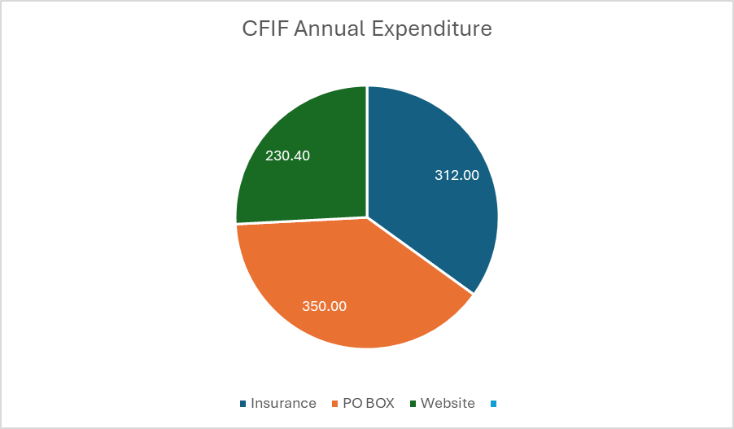

Fundraising Project

We were delighted to see the impact and response to the sports equipment that Simon took out last year to the Children’s Corner. Children’s Corners are community based, provide vital safe spaces where children can go to play and learn outside of schools. The Corners have trained community volunteers to become facilitators at the corners, who care, support and guide the children.

We are keen to continue this support. The 2 options available are to take collapsed balls out from the UK or with some additional funds to purchase the equipment needed out in Malawi. We are very keen to hear from sports clubs who might be interested in partnering on this initiative with us.

The Value of Books
We have continued to find ways of sending out books, journals etc to Malawi over the last 2 years and it’s clear how much these are appreciated once they arrive at their destination.
Do contact Chris Smith on weltonchris@yahoo.co.uk if you have any ideas about how we can raise awareness of this or have materials to donate. We are also still keen going forward to explore ways of enabling students and social workers to access online materials which give free access to research and academic publications.
Our Website, Social Media and Supporter’s Network
Our website is the place to look for news and fundraising information;https://www.childrenandfamiliesinternationalfoundation.org.uk/

We are currently planning to record a podcast profiling the work of SSWIM which will give provide more information about the history, development and future plans for this initiative. A link will be sent out to supporters once this has been completed to listen to and share with colleagues.

Our switch from Twitter to having a Linked In account is still a work in progress. Do link in with us www.linkedin.com/in/cfif-sswim and forward on our details to your friends and colleagues, particularly if they have an interest in Malawi.

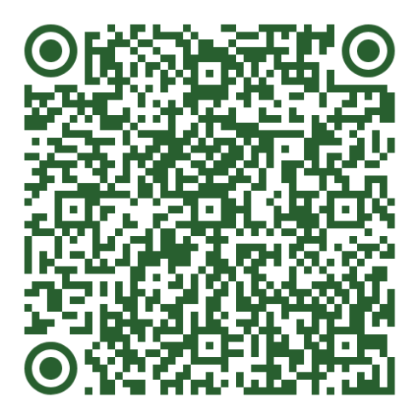
We have established a Just Giving page where supporters can set up either a monthly donation or one off contributions. Our fundraising page now includes this direct link to the Just Giving page.

Our Supporters Network was established in 2017, and individual members of the network have offered their support, and a small number have become more directly involved over time. SSWIM also benefits from continuing interest and support from BASW and the Malawi High Commission.

We are always interested to hear from any of our supporters who would like to become more actively involved with the Steering Group and looking to see how we can use the skills and experience of our interested supporters.

If you would be interested in becoming a trustee of CFIF or specifically in supporting the work of SSWIM we would be happy to welcome any supporters who would like to come and join us to explore their involvement further. For more details contact Chris Smith on weltonchris@yahoo.co.uk.
New Partnerships and future plans and priorities for the coming year
We have signed up in membership with the Scottish Malawi Partnership (SMP) who extended their membership to organisations not only based in Malawi but those working with Malawi and look forward to increasing our links with them.
Our Chair Anstance Fometu attended the IFSW Africa Conference in Senegal in 2025 which was the first French speaking country to host this event. She highlighted the extent to which issues around the movement of people are key social and social work issues and felt overall African social work is broadening its reach and depth. The IFSW Africa Conference in 2027 will be hosted in Malawi, providing an invaluable opportunity to highlight developments and to support ASWIM in their efforts to progress the publication and introduction of the Social Work Bill and SSWIM are looking forward to offering support for this event.
Ministerial Visit in February 2026
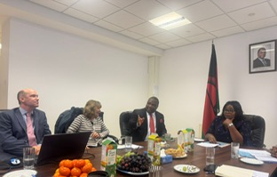
As we were getting ready to send out this newsletter, we had confirmation that the Minister of Gender, Children, Disability and Social Welfare in Malawi was going to visit the UK so we delayed sending the newsletter so we could include a few photos and feedback on her visit. More will be included in the next newsletter.
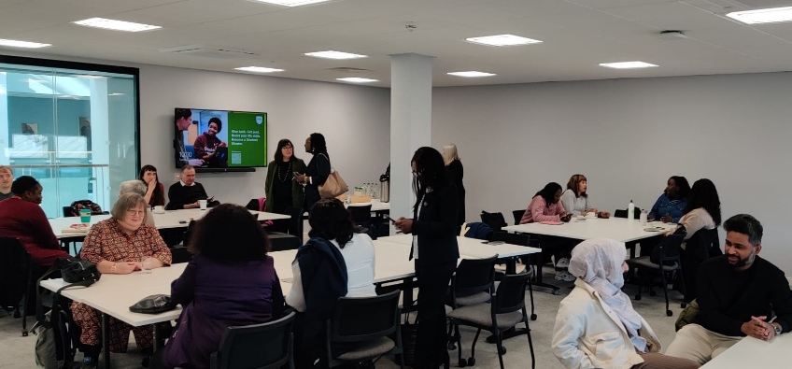
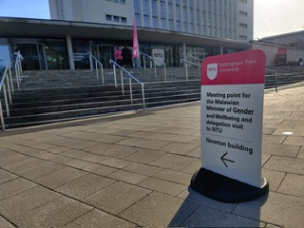
Our Chair of Trustees Anstance Fometu was involved in setting up the itinerary and some members of SSWIM were also involved. There were meetings at the Malawian High Commission which were attended by Chris Smith and a visit to Nottingham Trent University arranged by Dr Simon Cauvin and also attended by Dr Janet Walker. This led to an agreement to create and strengthen the links between Nottingham Trent University and Malawi – see announcement shared on social media below.

.
